ICO

📘 Definition
# Source: AI Source: Provided by: [Data Path: Persons Table -> ID Column: 1, Name_En Column: Motasem Essam] -> From: [ChatGPT] on [5/2/2026]
ICO is an image file format used mainly for icons in computer systems, applications, and websites. It stores small images that represent programs, files, or actions.

🧩 How ICO works
# Source: AI Source: Provided by: [Data Path: Persons Table -> ID Column: 1, Name_En Column: Motasem Essam] -> From: [ChatGPT] on [5/2/2026]
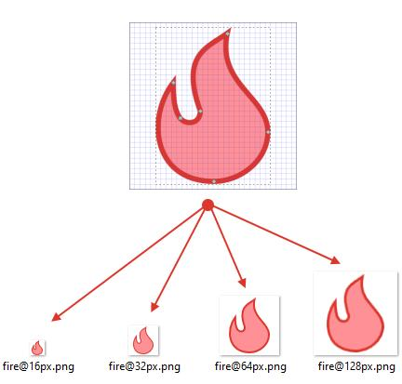
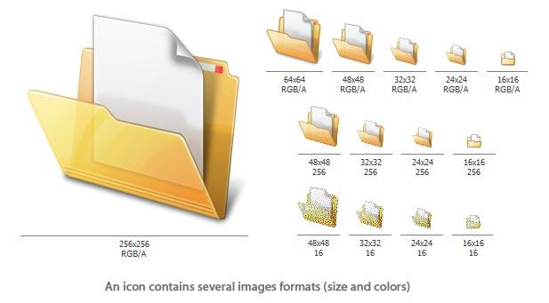

- An ICO file can store one or more small images
- Each image can have different sizes (16×16, 32×32, 64×64, etc.)
- The system chooses the best size depending on where it is used
- Used mainly for icons in interfaces

🧠 Simple example
# Source: AI Source: Provided by: [Data Path: Persons Table -> ID Column: 1, Name_En Column: Motasem Essam] -> From: [ChatGPT] on [5/2/2026]
Think of:
- 🖥️ Desktop icons (like folder, recycle bin, apps)
- 🌐 Website favicon (small icon in browser tab)
- 📱 App shortcuts on your computer
These often use ICO files.

💻 Where ICO is used
# Source: AI Source: Provided by: [Data Path: Persons Table -> ID Column: 1, Name_En Column: Motasem Essam] -> From: [ChatGPT] on [5/2/2026]
- 🖥️ Windows desktop icons
- 🌐 Website favicons (browser tab icons)
- 📂 Software applications
- 🎮 Game launchers and tools

⚙️ Key features
# Source: AI Source: Provided by: [Data Path: Persons Table -> ID Column: 1, Name_En Column: Motasem Essam] -> From: [ChatGPT] on [5/2/2026]
- 🧩 Designed for icons and small graphics only
- 📏 Supports multiple sizes in one file
- 🎨 Can include transparency
- 📁 Very small file size

🚀 In short:
# Source: AI Source: Provided by: [Data Path: Persons Table -> ID Column: 1, Name_En Column: Motasem Essam] -> From: [ChatGPT] on [5/2/2026]
ICO = a file format used to store small icon images for apps, folders, and websites.

